MagnoliaMeridian.com
an effort to improve Magnolia Cemetery
Would your family or community group be willing to adopt a section of Magnolia Cemetery?
This effort will launch with a community work morning on Saturday, May 4th, 8:30am-12N. When you sign up to volunteer, tell us how many people you expect in your group. If you would like to select a certain section of the cemetery in which to work, that is possible (the sections are numbered in the attached map). Once you sign up, we will try to provide an area of the cemetery that is right sized for the number in your group to be able to complete your tasks within three hours or less. If you would like to volunteer individually, we can put you with other groups, but you still need to sign up in advance.
As a volunteer, what will you do?
-Pick up trash in your section including the tiny pieces of flowers that blow off graves.
-Hand trim weeds and grass not properly trimmed with a weed eater.
-Clean headstones that are especially dirty with water and cloth.
-Raking in some sections as needed, especially where there are trees.
-Weed eating/raking curb and gutters along the road in your section. (Volunteers will not be weed eating around markers and monuments, only alongside the road in your respective section.)
What does your family or group need to bring?
-Gardening gloves
-Rake/s
-Hand held pruners or trimmers
-Garbage bags
-Bucket
-A gallon of water/old rags
-Weed eater/s and safety glasses if your section borders a street. Everyone who is weed eating must be at least 15 years of age.
Following this initial “community” workday at the cemetery, we ask that your group commit to clean up your assigned section two other times over the next 12 months, ideally before Thanksgiving and before next Easter, 2025. This can be done on your own schedule.
Rain Date: Saturday, May 11th 8:30am-12N—Check our Facebook page for updates if rain is forecasted.

Sign Up:
Our family or community group would like to adopt a section of Magnolia Cemetery and would like to participate in the community work morning on Saturday, May 4th from 8;30am-12N. If you are an individual or couple you can use this sheet to sign up and we will place you with another group.
Name of Family or Group:
Group Leader Name:
Email Address:
Phone Number:
Number of people expected in your group (an estimate is fine):
Is there an area of the cemetery you would like to adopt? Please specify using the map included. If you want to adopt a portion of a section, you can describe that or draw on the map and return to us by mail, email or give back to the person who asked you to sign up.
We would like to adopt section _______ or a portion of section _________ (describe the section, ie, left, right, middle, top, bottom)
If your section borders a street, will someone in your group be able to weed eat?
YES or NO
On the morning of the workday each person participating will be asked to sign the waiver attached.
Please return this form as soon as possible, completing the sections in bold. If you don’t want to select a specific section of the cemetery, we will pick an area that is right sized for your group. If it is more convenient, you may simply answer the questions in bold by email.

Thank you, Tracey Jones

Email address: tjones@magnoliameridian.com
Mailing Address: 171 Dolphin Cove, Freeport, FL 32439
Questions: 540-246-1027

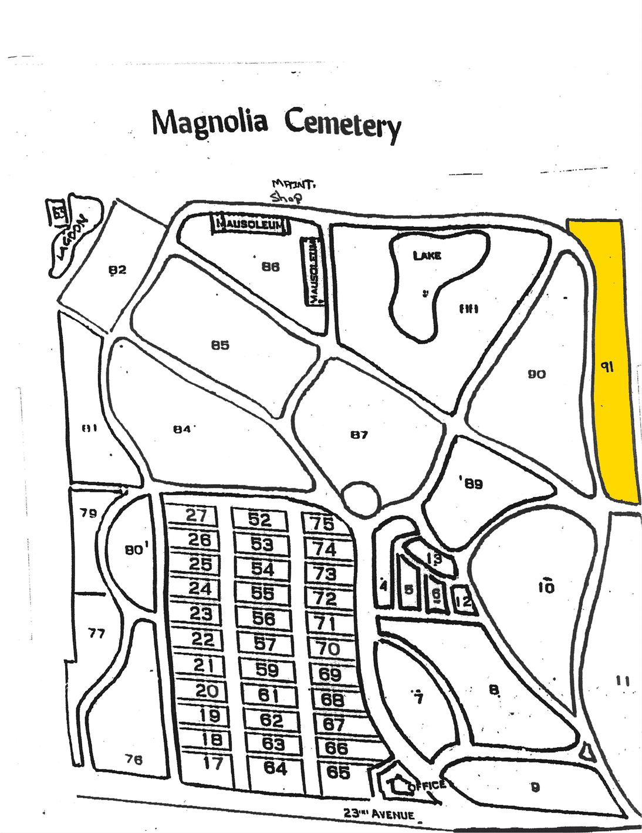

RELEASE

I, ___________________________, do hereby release, discharge and hold harmless Magnolia Cemetery, located at 2638 23rd Avenue, Meridian, Mississippi 39305, and its owners, employees, agents and assigns from any and all injuries I may receive while participating in a volunteer clean up event at the cemetery.
This also acknowledges that this Release is signed voluntarily and of my own accord.
WITNESS MY SIGNATURE on this the _____ day of _____________________, 2024.
_________________________________
NAME

________________________________
WITNESS

